- Users table:
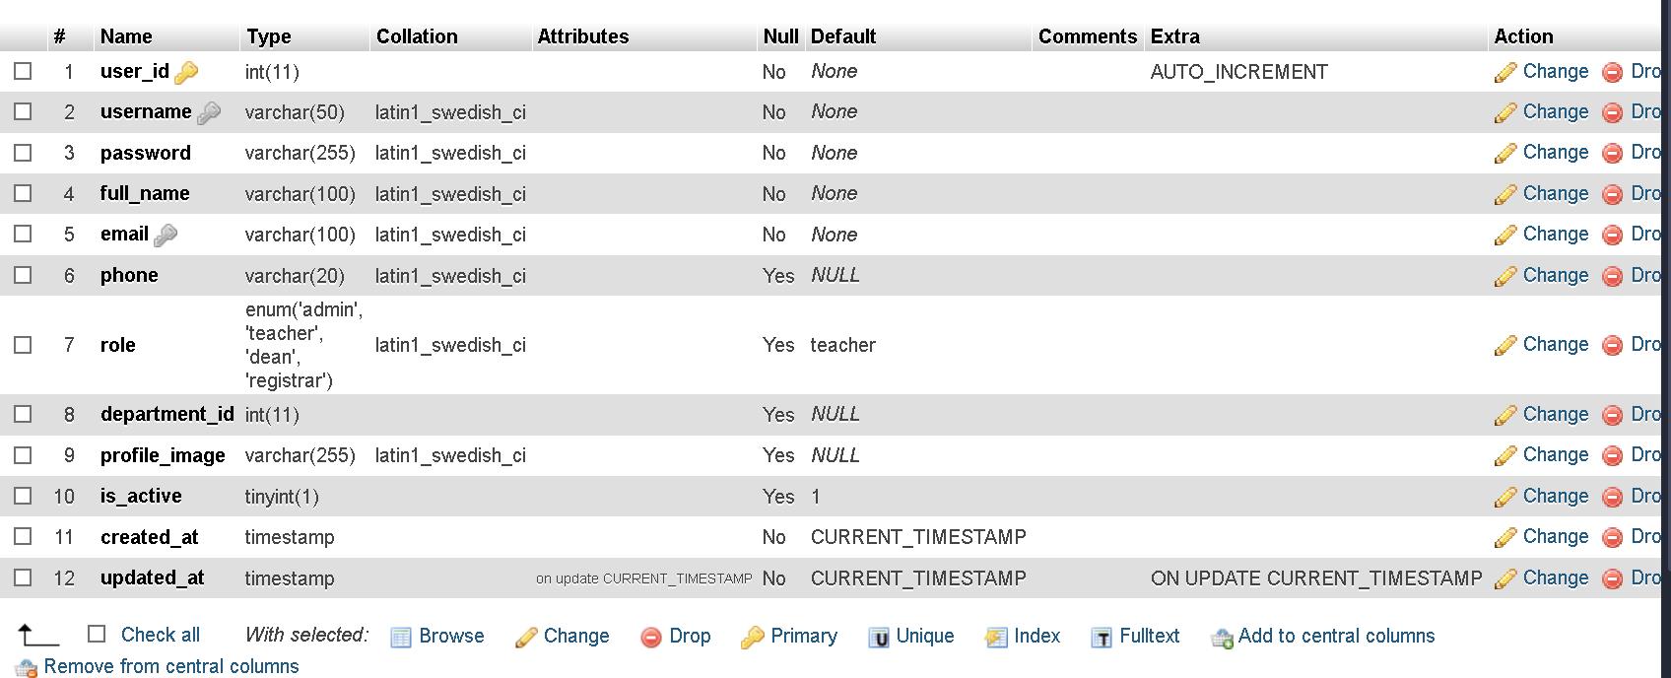
- Teacher table: I don’t have teachers table since teachers saved in the user table when they created. They are classified by their role from another user in that table.
- Student table
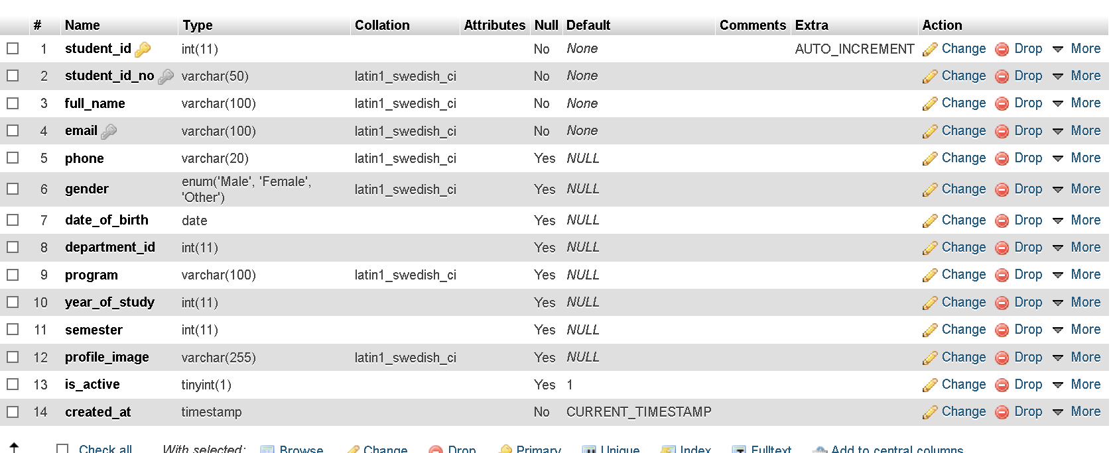
- Departments table:
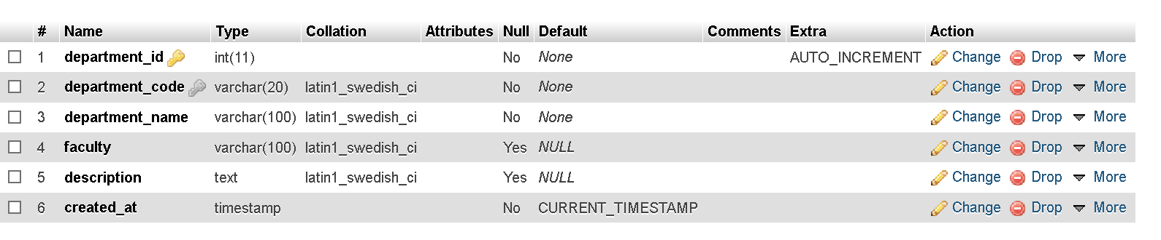
- Courses table:
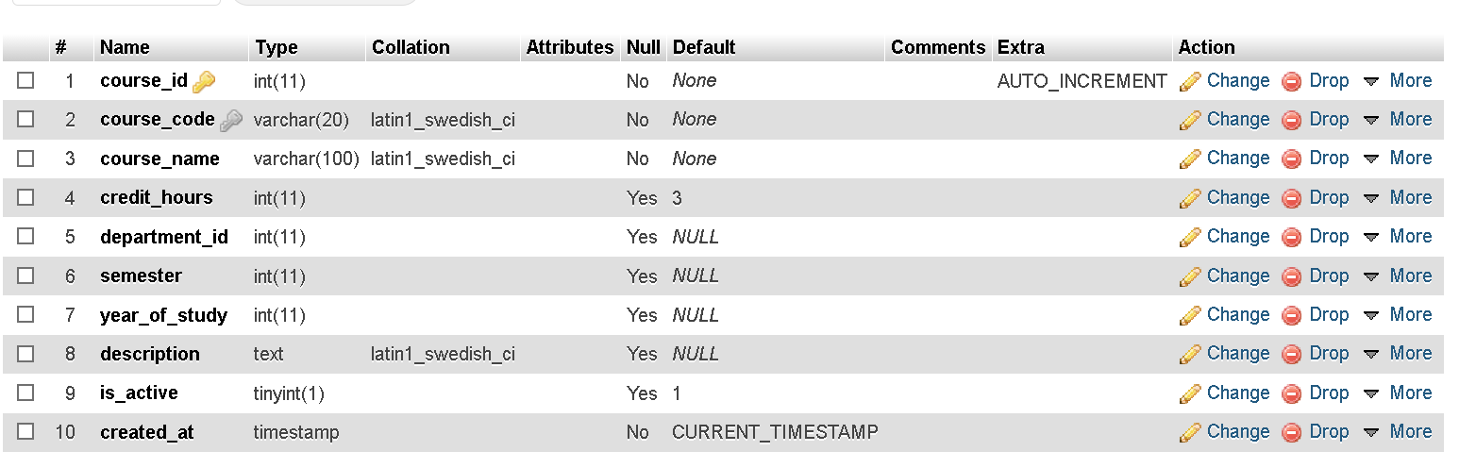
- Course_students: I don’t have course students table, create it for me
- Class_schedule: I don’t have class schedule table too, create it for me
- Attendance_records: In case of mine its name is Attendance which is:
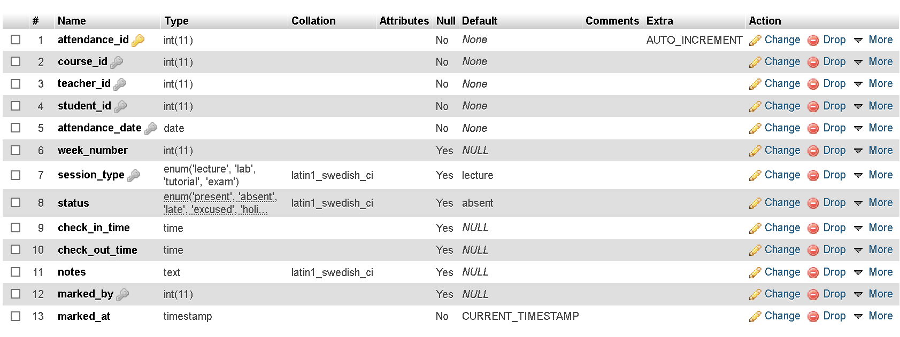
Finally the structure of dadu_attendance_system database looks like:


